**TITLE OF YOUR PAPER**

**First Author1, Second Author2, Third Author1,2,**

**1First affiliation, Address, City, Country, First Author e-mail@xxx.xxx.xx**

**2Second affiliation, Address, City, Country, Second Author e-mail@xxx.xxx.xx**

**Abstract**

Your abstracts should be between 200-400 words and should include the name, surname, place of employment and e-mail addresses of all authors involved in the paper. All letters in the title should be capitalized and centered. Margins should be 2 cm. The font should be Times New Roman, 12 Punto and single line spacing. At least three keywords should be included. Your abstracts must be uploaded in word/doc format via the relevant congress system. Your abstracts should be between 200-400 words and should include the name, surname, place of employment and e-mail addresses of all authors involved in the paper. All letters in the title should be capitalized and centered. Margins should be 2 cm. The font should be Times New Roman, 12 Punto and single line spacing. At least three keywords should be included. Your abstracts must be uploaded in word/doc format via the relevant congress system. Your abstracts should be between 200-400 words and should include the name, surname, place of employment and e-mail addresses of all authors involved in the paper. All letters in the title should be capitalized and centered. Margins should be 2 cm. The font should be Times New Roman, 12 Punto and single line spacing. At least three keywords should be included. Your abstracts must be uploaded in word/doc format via the relevant congress system.

***Keywords*:** Keyword1, keyword2, keyword3

**1. Introduction**

Write the purpose/importance, theoretical/conceptual framework of your study here, including references (12 pt). Here introduce the paper, and put a nomenclature if necessary, in a box with the same font size as the rest of the paper. The paragraphs continue from here and are only separated by headings, subheadings, images and formulae. The section headings are arranged by numbers, bold and 12 pt. Here follow further instructions for authors.

**2.  Material and Methods**

All figures should be numbered with Arabic numerals (1,2,...n). All photographs, schemas, graphs and diagrams are to be referred to as Figures. Line drawings should be good quality scans or true electronic output. Low-quality scans are not acceptable. Figures must be embedded into the text and not supplied separately. Lettering and symbols should be clearly defined either in the caption or in a legend provided as part of the Figure. Figures should be placed at the top or bottom of a page wherever possible, as close as possible to the first reference to them in the paper.

The figure number and caption should be typed below the illustration in 12 pt and mid justified. Artwork has no text along the side of it in the main body of the text. However, if two images fit next to each other, these may be placed next to each other to save space, see Fig 1. They must be numbered consecutively, all figures, and all tables respectively.

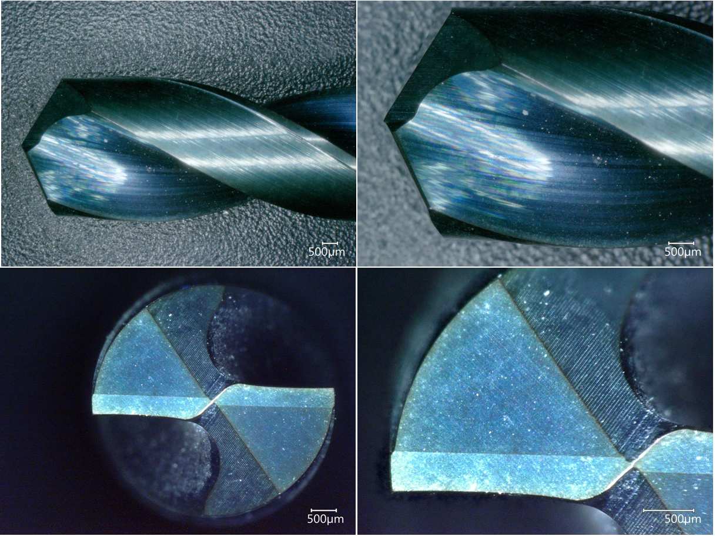

**Fig. 1.** (a) first picture; (b) second picture

Equations and formulae should be typed and numbered consecutively with Arabic numerals in parentheses on the right hand side of the page (if referred to explicitly in the text),

 (1)

They should also be separated from the surrounding text by one space.

**3. Results and Discussion**

Write the findings of your study in this section. If you are going to use tables and figures in your study, organize them according to the examples given below. All tables should be numbered with Arabic numerals. Headings should be placed above Tables, left justified. Leave one line space between the heading and the table. Only horizontal lines should be used within a table, to distinguish the column headings from the body of the table, and immediately above and below the table. Tables must be embedded into the text and not supplied separately. Below is an example which authors may find useful.

**Table 1** An example of a table

|  |  |  |
| --- | --- | --- |
| An example of a column heading | Column A (*t*) | Column B (*T*) |
| And an entry | 1 | 2 |
| And another entry | 3 | 4 |
| And another entry | 5 | 6 |

**4. Conclusion**

**References**

The references in the paper should be cited using the number in square brackets [1]. Moreover, the references should be numbered as the order that they are presented throughout the manuscript: [1] [2] [3]. All references listed must be cited, and all cited references must be included in the reference list. One of the APA or MLA systems can be used according to the author's preference. At the end of the text, a list of the sources used in the study is given under the heading References. This bibliography, in which the references used in the study are listed, should be prepared alphabetically and in the order of the author's surname.